**Exercise 4.b. – Form Validation using RegEx**

**Name:** Badri MSV **Roll No:** 195002017

**Subject:** UIT1611 – Web Programming Lab **Faculty:** Dr. S. Sasirekha

**Date:**

**Aim:**

To Validate all the fields of your Form with appropriate constraints.

**Code:**

main.html

<html>

<head>

    <title>RegEx Form Validation</title>

</head>

<body align="center">

    <h1>Registration Form</h1>

    <form name="myform"  method="post" onsubmit="return formValidation()" action="jsregexassgn_suc.html">

        <label for="uid">User ID:</label>

        <input type="text" name="uid" id="uid" required>

        <br>

        <br>

        <label for="pwd">Password</label>

        <input type="password" name="pwd" id="pwd" required>

        <br>

        <br>

        <label for="cntry">Country:</label>

        <select id="country" name="country" required>

           <option selected="" value="Default">(Please select a country)</option>

           <option value="Australia">Australia</option>

           <option value="China">China</option>

           <option value="Egypt">Egypt</option>

           <option value="Finland">Finland</option>

           <option value="Germany">Germany</option>

           <option value="Great Britain">Great Britain</option>

           <option value="India">India</option>

           <option value="Japan">Japan</option>

           <option value="Macedonia">Macedonia</option>

           <option value="Russia">Russia</option>

           <option value="United Kingdom">United Kingdom</option>

           <option value="Ukraine">Ukraine</option>

           <option value="United States of America">United States of America</option>

        </select>

        <br>

        <br>

        <label for="zip">Zip Code:</label>

        <input type="number" name="zip" id="zip" required>

        <br>

        <br>

        <label for="email1">Email:</label>

        <input type="email" name="email1" id="email1" required>

        <br>

        <br>

        <h3>Sex:</h3>

        <input type="radio" name="sex" id="sex" value="male" required>

        <label for ="male">Male</label>

        <input type="radio" name="sex" id="sex" value="female" required>

        <label for ="female">Female</label>

        <br>

        <br>

        <input type="checkbox" name="en" value="en" checked /><span>English</span>

        <input type="checkbox" name="nonen" value="noen" /><span>Non English</span>

        <br>

        <br>

        <label for="about">About:</label>

        <textarea placeholder="Type something about you if you wish to"></textarea>

        <br>

        <br>

        <button type="submit">Submit</button>

    </form>

</body>

<script type="text/javascript">

    function formValidation(){

        var uid = document.myform.uid;

        var passid = document.myform.pwd;

        var ucountry = document.myform.country;

        var uzip = document.myform.zip;

        var uemail = document.myform.email;

        var umsex = document.myform.sex;

        if(userid_validation(uid,5,12)){

            if(passid_validation(passid,7,12)){

                if(allLetter(uid)){

                        if(countryselect(ucountry)){

                            if(allnumeric(uzip)){

                                if(ValidateEmail(uemail)){

                                }

                            }

                        }

                }

            }

        }

        return false;

    }

    function userid_validation(uid,mx,my){

        var uid_len = uid.value.length;

        if (uid_len == 0 || uid_len >= my || uid_len < mx){

            window.alert("User Id should not be empty / length be between "+mx+" to "+my);

            uid.focus();

            return false;

        }

        return true;

    }

    function passid_validation(passid,mx,my){

        var passid_len = passid.value.length;

        if (passid_len == 0 ||passid_len >= my || passid_len < mx){

            window.alert("Password should not be empty / length be between "+mx+" to "+my);

            passid.focus();

            return false;

        }

        return true;

    }

    function countryselect(ucountry){

        if(ucountry.value == "Default"){

            window.alert('Select your country from the list');

            ucountry.focus();

            return false;

        }

        else{

            return true;

        }

    }

    function allnumeric(uzip){

        var numbers = /^[0-9]+$/;

        if(uzip.value.match(numbers)){

            return true;

        }

        else{

            window.alert('ZIP code must have numeric characters only');

            uzip.focus();

            return false;

        }

    }

    function ValidateEmail(uemail){

        var mailformat = /^\w+([\.-]?\w+)*@\w+([\.-]?\w+)*(\.\w{2,3})+$/;

        if(uemail.value.match(mailformat)){

            return true;

        }

        else{

            window.alert("You have entered an invalid email address!");

            uemail.focus();

            return false;

        }

    }

</script>

</html>

success.html

<html>

<head>

    <title>Submission success</title>

</head>

<body>

    <h1>Submission successful</h1>

</body>

</html>

**Output:**

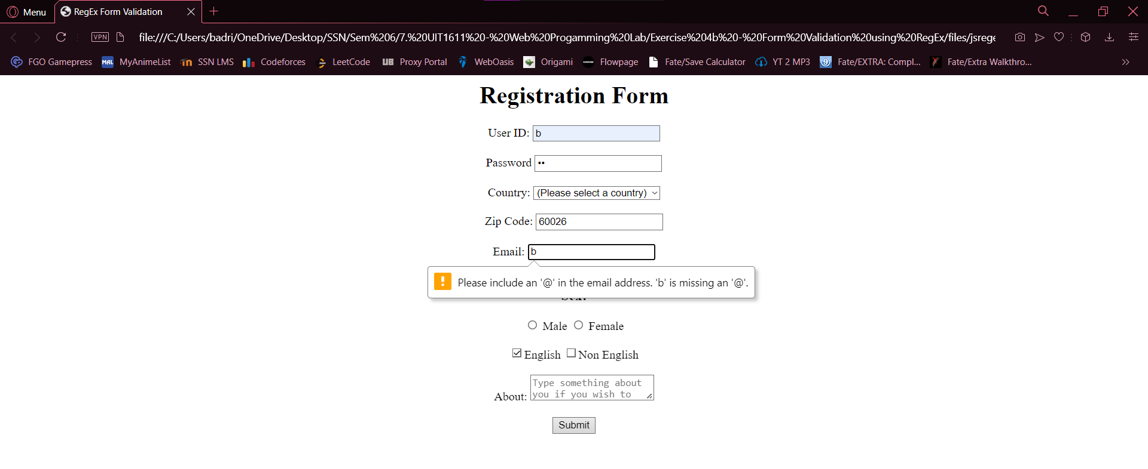

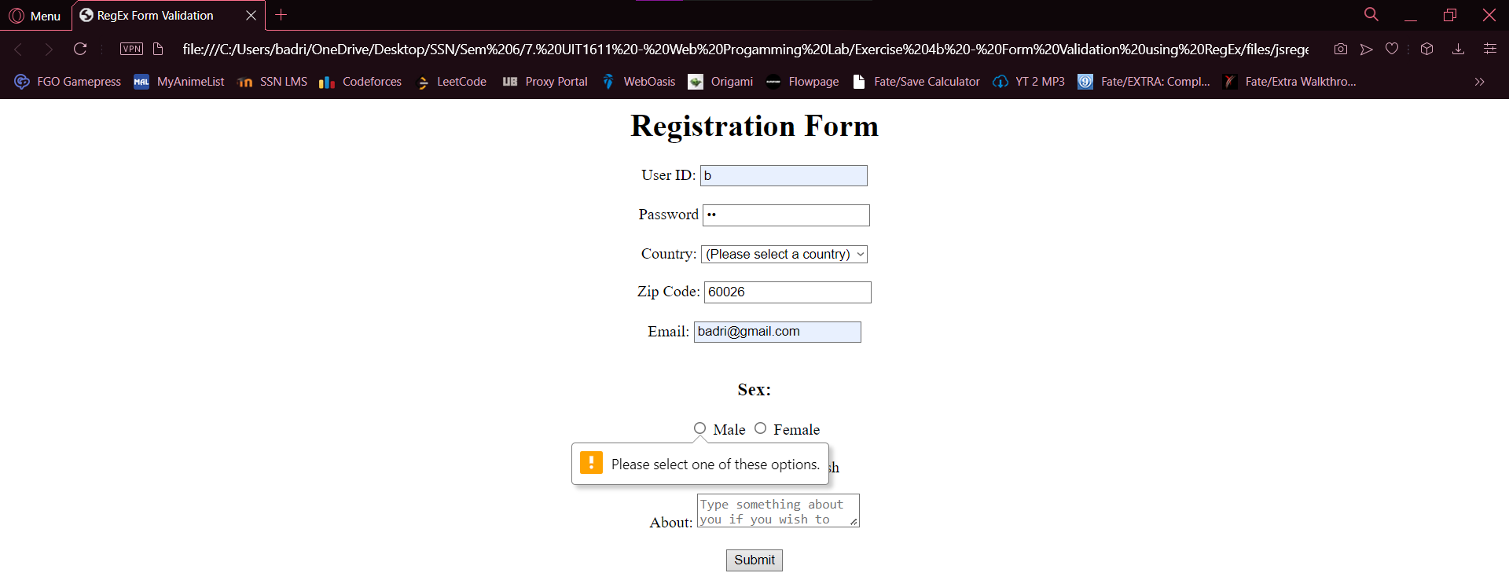

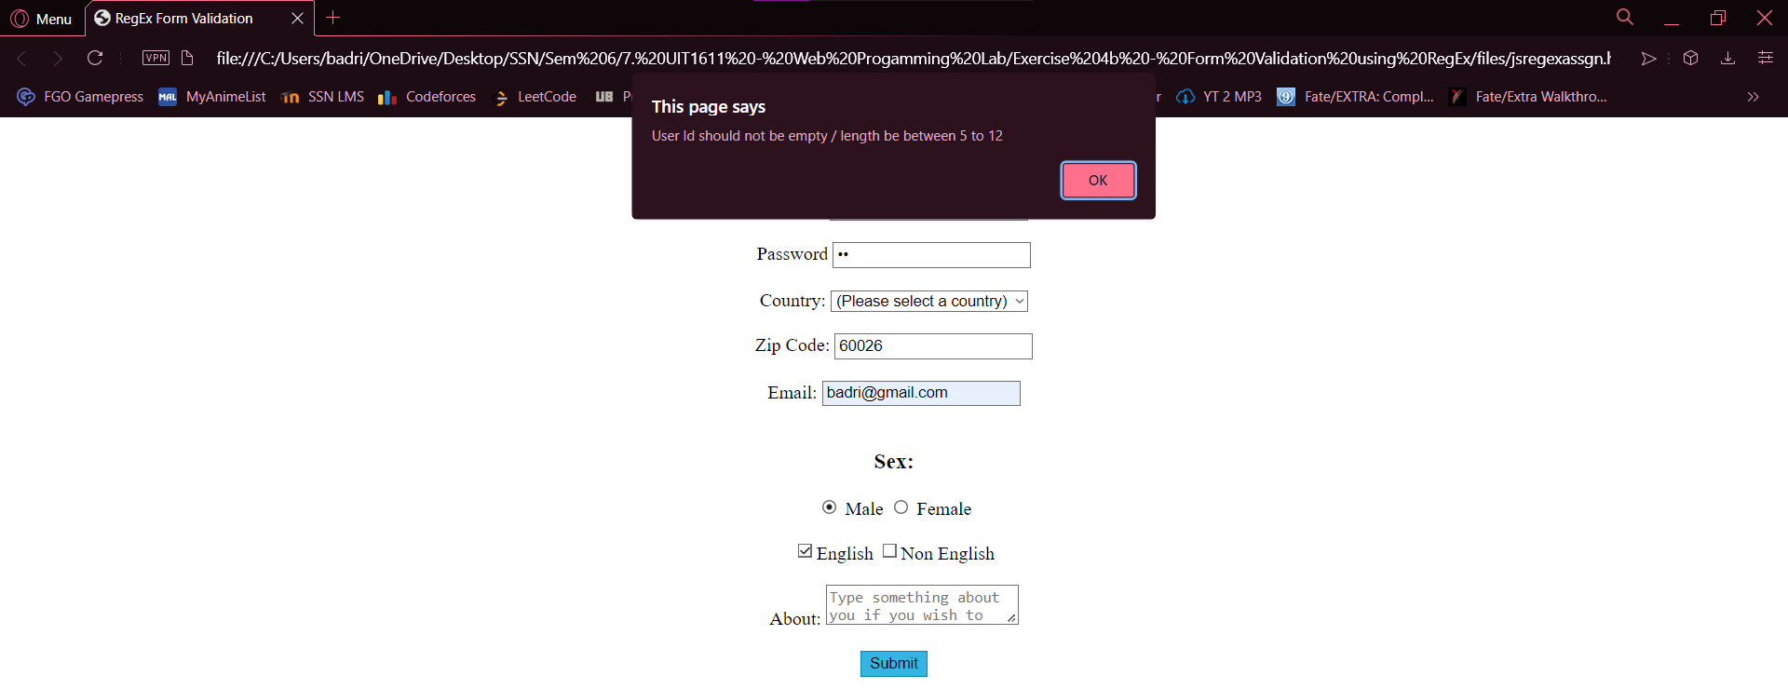

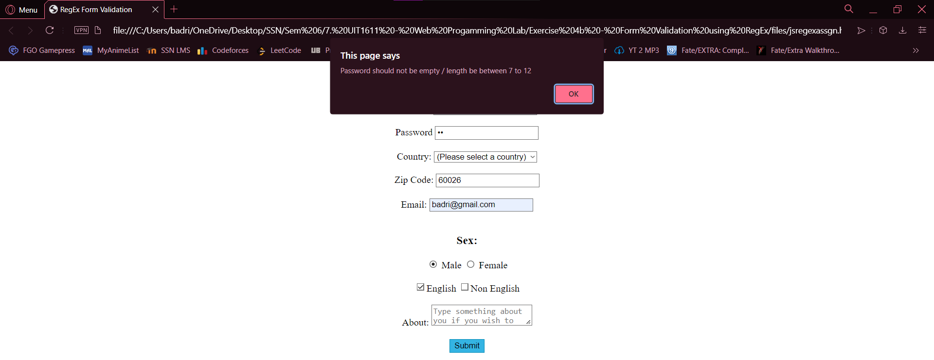

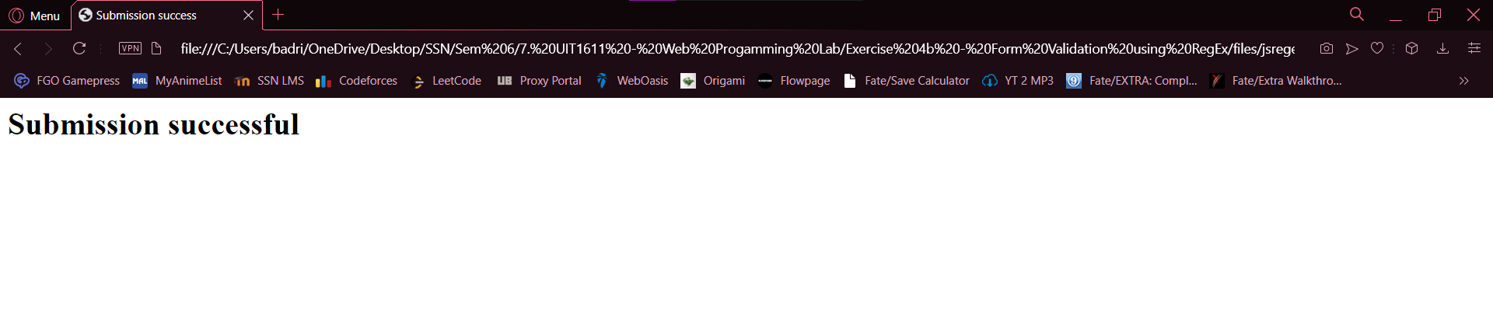

**Result:**

Thus, the form was validated using Regular Expressions in JavaScript functions and was submitted successfully.